INFRASTRUCTURE-1
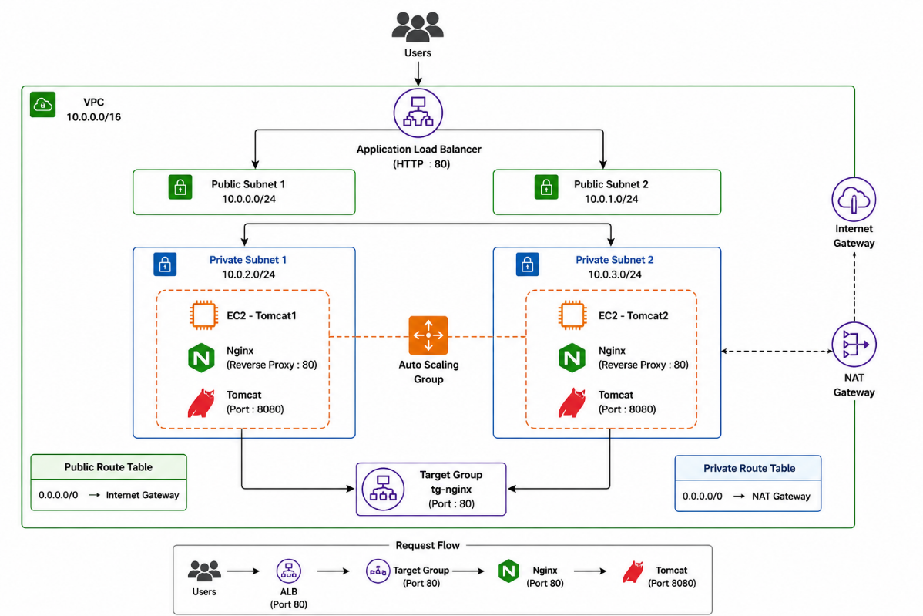
- create a vpc-(my-vpc)-(10.0.0.0/16)
- create a subnet
- public-subnet-1 (az-1a) (10.0.0.0/24)
- public-subnet-2 (az-1b) (10.0.1.0/24)
- private-subnet-3 (az-1a) (10.0.2.0/24)
- private-subnet-4 (az-1b) (10.0.3.0/24)
- create a internet-gateway and attach to vpc (my-vpc)
- create a nat-gateway regional (my-vpc)
- create a route-table
- public-route-table
- associate-public-subnet 1&2
- edit routes ---> 0.0.0.0/0 -> internet-gatway
- private-route-table
- associate-private-subnet 3&4
- edit routes ---> 0.0.0.0/0 -> nat-gatway
6. create a launch-template
- name ----> mylt
- tags ------> Name-tomcat
- instance_type ----> t3.micro
- os_machine --> amazon-linux
- key_pair -------> ubuntu
- create a security group
- name ----> my-sg
- vpc -----> my-vpc
- permission --> ssh/http/https/All-TCP
- create a template
7. create a autoscaling group
- name ----> ASG
- lt ------> mylt
- subnets -> private 3&4
- create a autoscaling group
8. create a bastion-host-server
- access the bastion-host-server --> get the access-tomcat1
- sudo dnf update -y
- sudo dnf install java-17-amazon-corretto-devel -y
- wget https://dlcdn.apache.org/tomcat/tomcat-9/v9.0.118/bin/apache-tomcat-9.0.118.tar.gz
- tar -xzf apache-tomcat-9.0.118.tar.gz
- cd apache-tomcat-9.0.118
- cd bin
- chmod +x catalina.sh
- ./catalina.sh start
- curl localhost:8080
9. access tomcat-2 on bastion-host-server
- sudo dnf update -y
- sudo dnf install java-17-amazon-corretto-devel -y
- wget https://dlcdn.apache.org/tomcat/tomcat-10/v10.1.55/bin/apache-tomcat-10.1.55.tar.gz
- tar -xzf apache-tomcat-10.1.55.tar.gz
- cd apache-tomcat-10.1.55
- cd bin
- chmod +x catalina.sh
- ./catalina.sh start
- curl localhost:8080
10.create a target-group
- name ----> tg
- vpc -------> my-vpc
- register -> tomcat1 & tomcat2
- 8080 -----> include as pending below
- create a target group
11.create a load-balancer
- name ----> ALB
- vpc -----> my-vpc
- az ------> public-subnet 1&2
- tg ------> tg
- create a load-balancer
12.Copy the DNS & hit it on web
- http://alb-869679179.ap-south-1.elb.amazonaws.com:8080/
TO HIDE THE PORT:8080 (IMPLEMENTING NGINX-REVERSE-PROXY)
13.Access tomcat-1 on bastion-host-server
- sudo dnf update -y
- sudo dnf install nginx -y
- sudo systemctl enable nginx
- sudo systemctl start nginx
- sudo systemctl status nginx
- vim /etc/nginx/nginx.conf
server {
listen 80;
listen [::]:80;

server_name _;

location / {
proxy_pass http://localhost:8080;

proxy_set_header Host $host;
proxy_set_header X-Real-IP $remote_addr;
proxy_set_header X-Forwarded-For $proxy_add_x_forwarded_for;
}

error_page 404 /404.html;
location = /404.html {
}

error_page 500 502 503 504 /50x.html;
location = /50x.html {
}
}
7. nginx -t
8. sudo systemctl restart nginx
9. curl localhost
14.Same steps for the tomcat-2
15.create a new target-group
- name ---> tg-nginx
- vpc ------> my-vpc
- register---> tomcat 1&2
- port ---> 80 ---> include as a pending below
- register targets
16.configure load-balancer
- click on listener ---> add listener
- http ----> 80
- forward to tg ---> tg-nginx
- create
17.copy the dns name
- http://alb-869679179.ap-south-1.elb.amazonaws.com

